SPRING

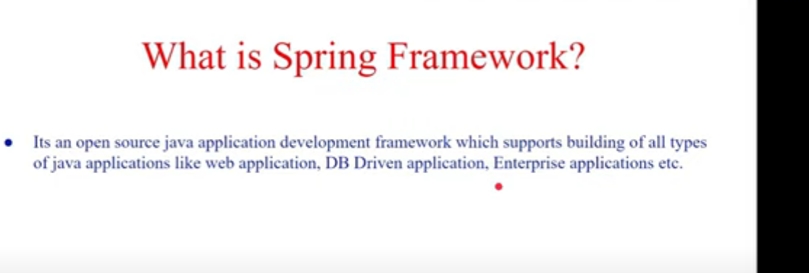

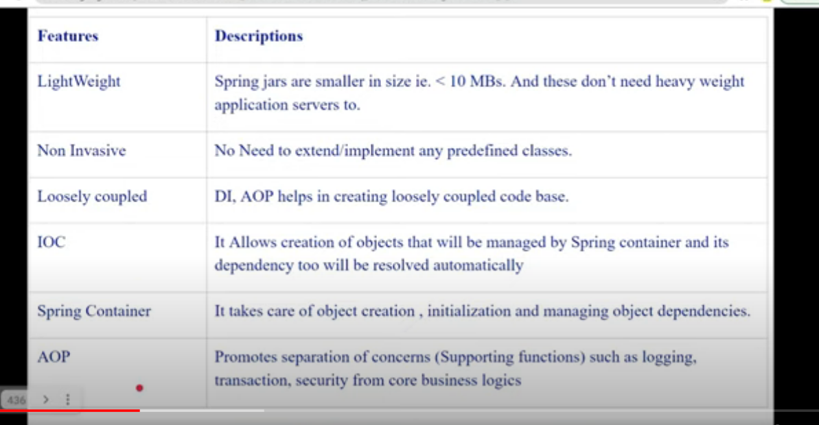

Spring Container

All the objects are present in spring container and it manages those objects i.e it’s creation , lifecycle and destruction of these objects.

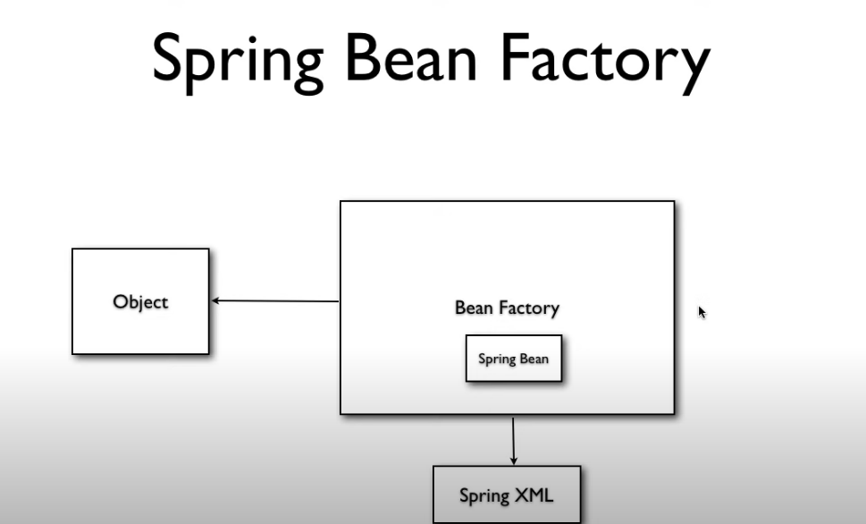

It is used to create new object and for creating these objects it refers a xml file.

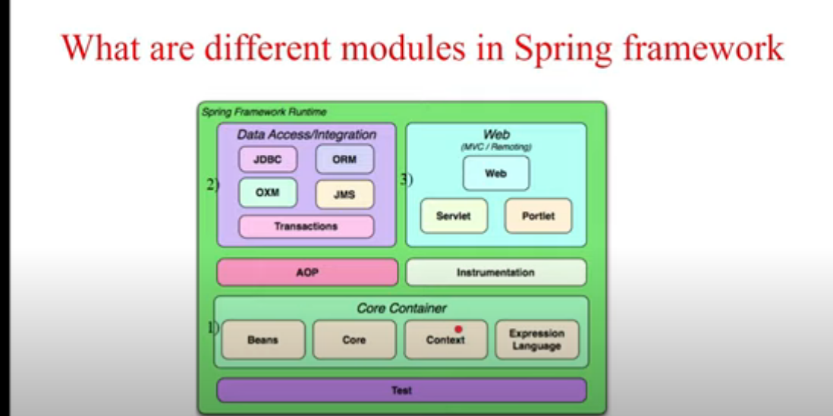

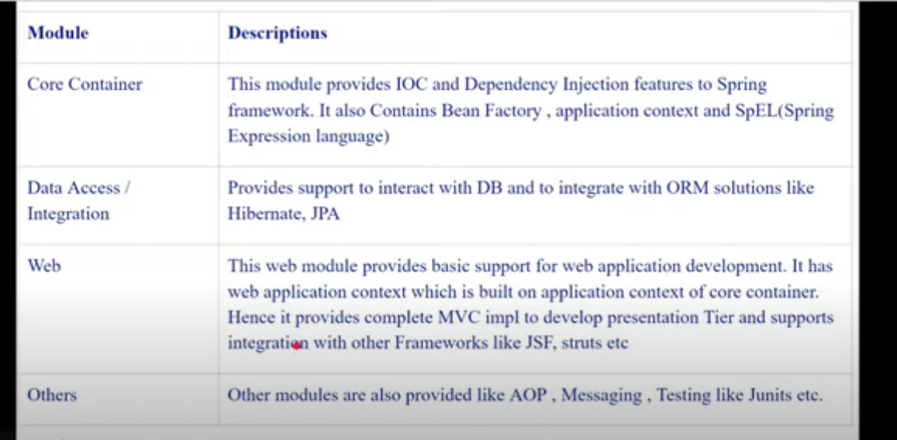

<https://www.geeksforgeeks.org/spring-component-annotation-with-example/>

Spring Beans

In Spring, the objects that form the backbone of your application and that are managed by the Spring IoC container are called beans. A bean is an object that is instantiated, assembled, and otherwise managed by a Spring IoC container.

https://www.baeldung.com/spring-bean#:~:text=Bean%20Definition&text=In%20Spring%2C%20the%20objects%20that,by%20a%20Spring%20IoC%20container.

Simple implementation of Spring

1. Create a Bean Class

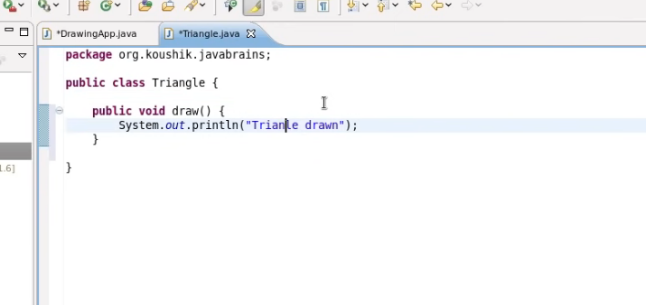

1. Create instance of Triangle through spring

The spring will search for bean with id triangle in the spring.xml file.

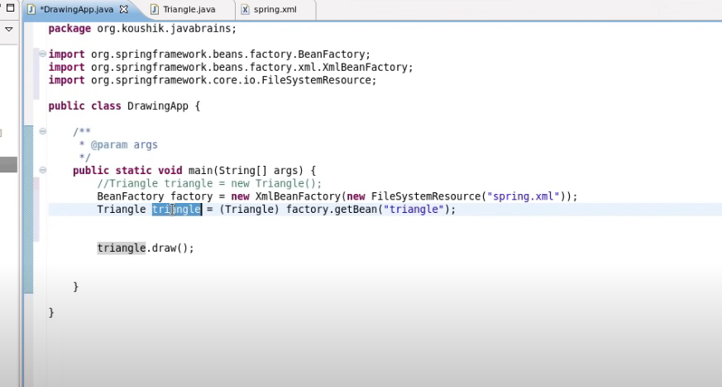

We may also use ApplicationContext instead of BeanFactory as used below:

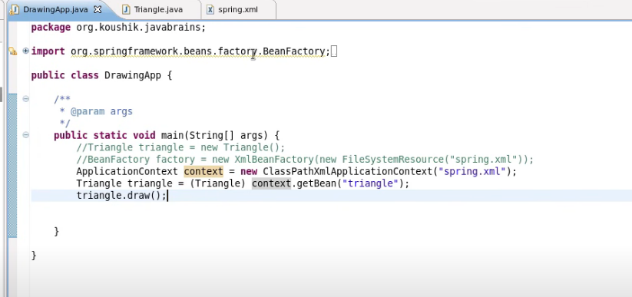

1. Create a xml file that will provide bean of Triangle, properties can also be added with spring bean.

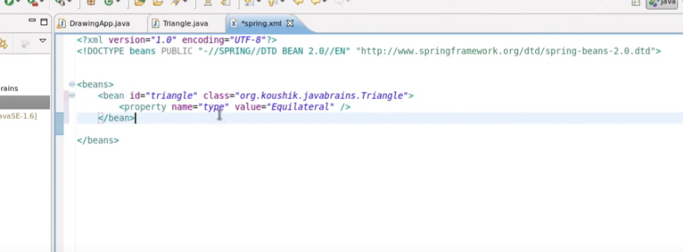

There are 3 types of configuration metadata

1. Xml based
2. Annotation based
3. Java Based

In xml and java based configuration, all the configurations are mentioned in the same file, so it is more readable and performance is also high.

In the annotation-based configuration, performance is low as spring has to scan all the packages to check for beans.

Dependency Injection

Beans can be injected in 2 ways:

1. Setter injection

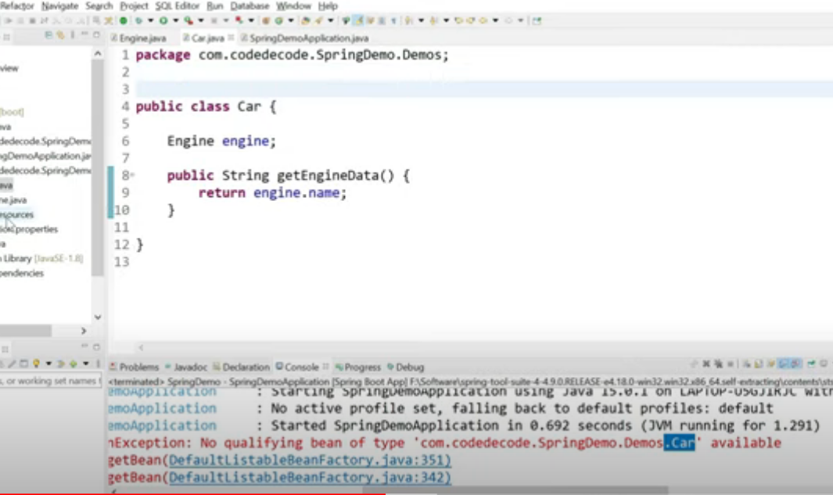

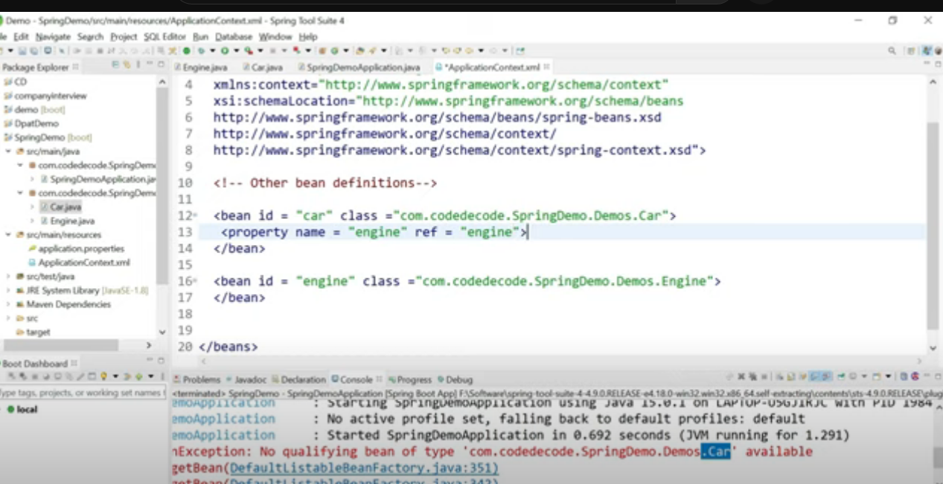

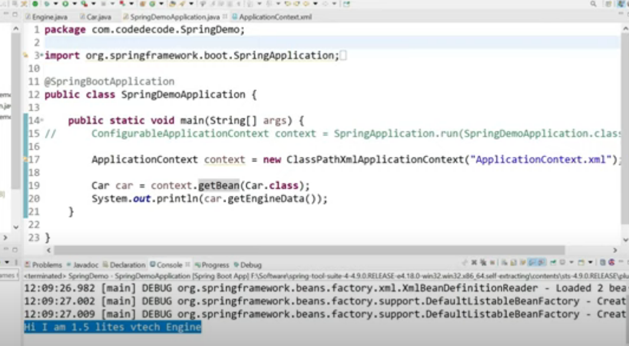

1. Constructor injection

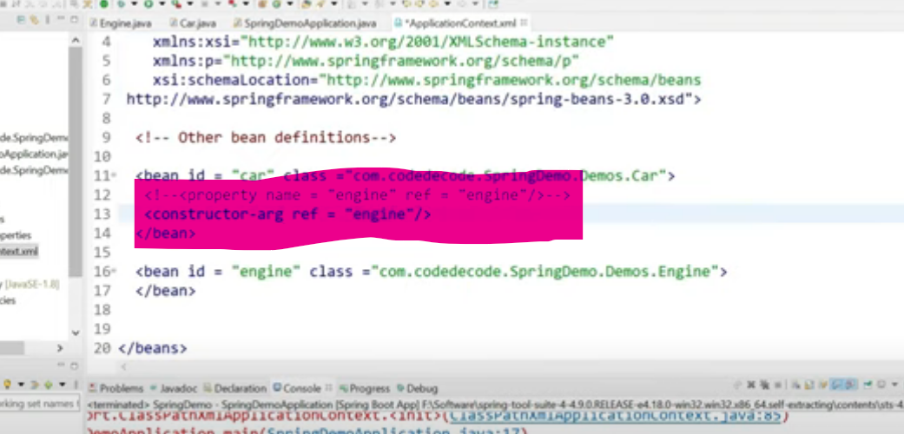

Inorder to provide value in constructor-arg we may use below syntax :

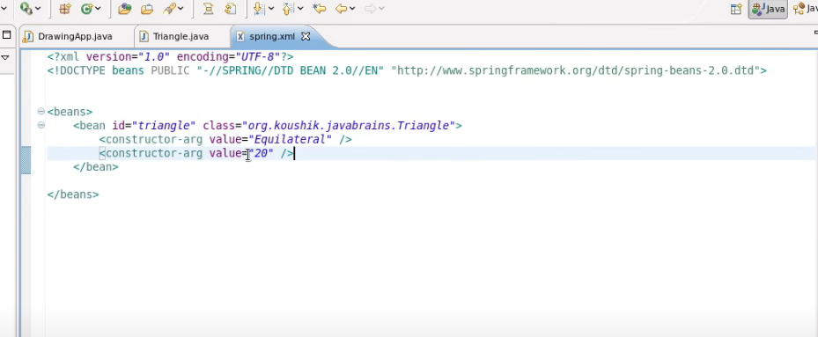

We may also specify the type of value while providing constructor arguments in the xml file as displayed below:

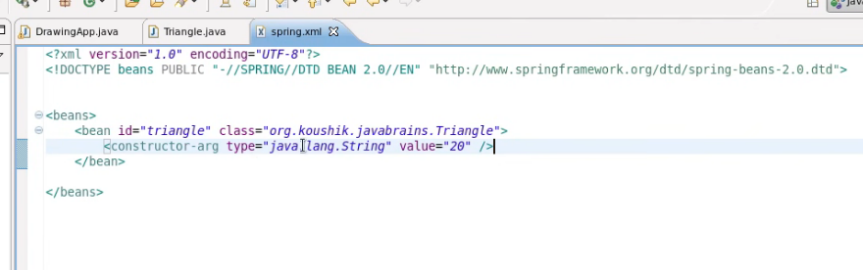

We may also specify the index(or order of the arguments which are to be mapped with the constructor)

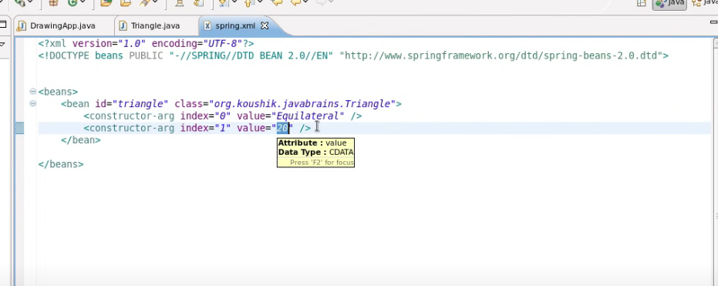

We also need to create constructor in Car glass.

There are 2 ways of creating context to get beans as highlighted above:

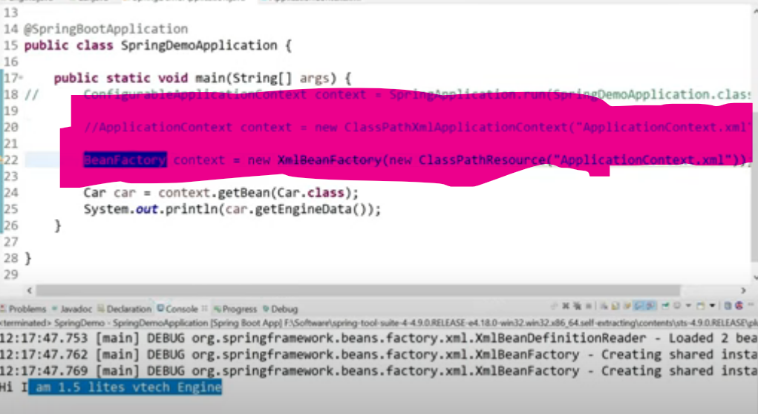

The ApplicationContext/Beanfactory both are used to initilaize spring container.

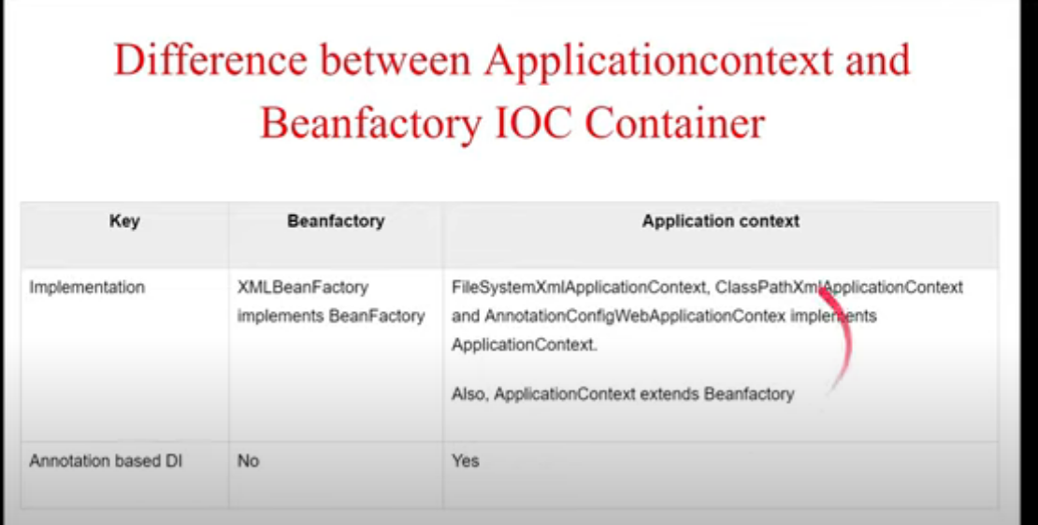

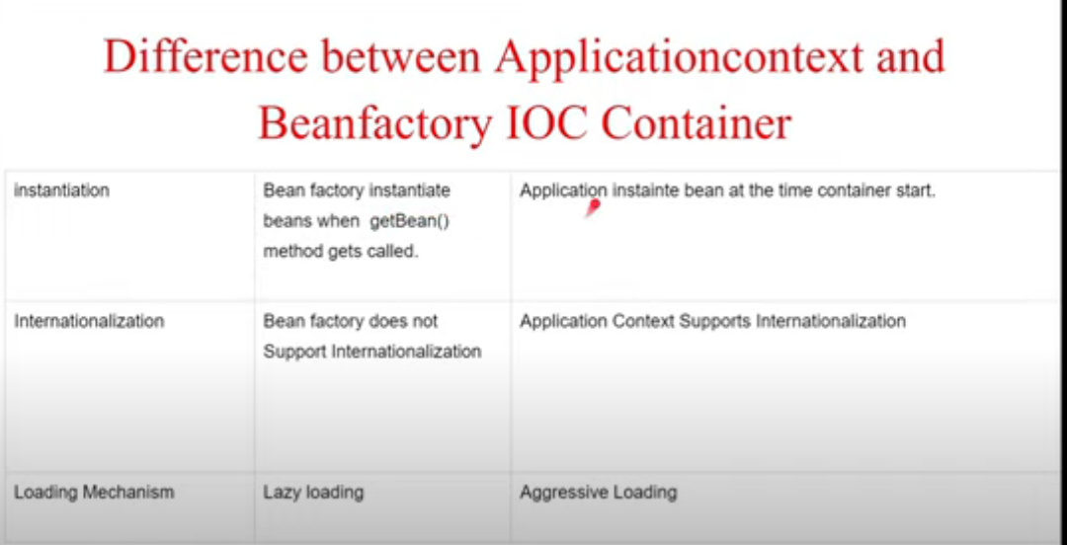

Incase of applicationContext, memory is allocated as soon as applocationContext is initialized.

The bean references can also be created as displayed in the below example:

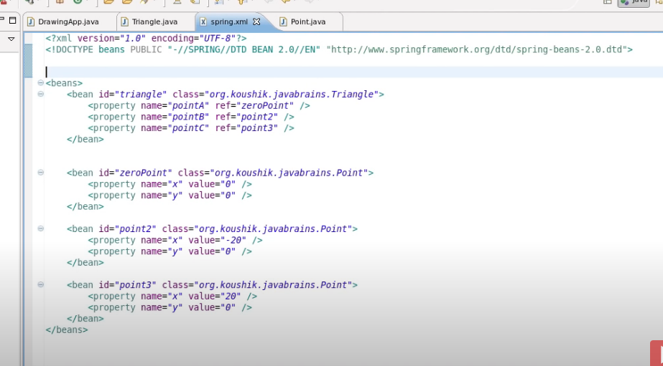

Inner beans

We may also create beans inside bean in spring.

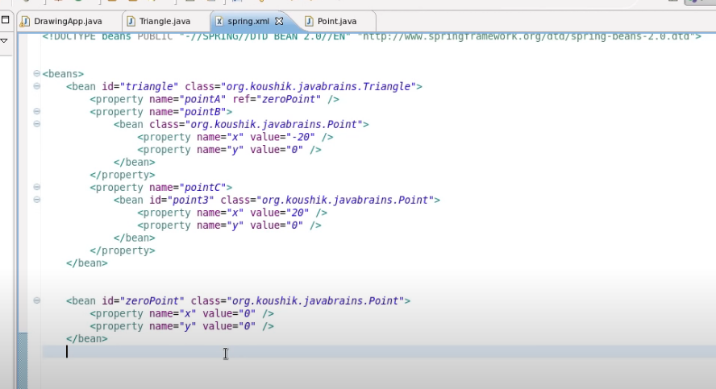

We can also inject a list of beans, as displayed below:

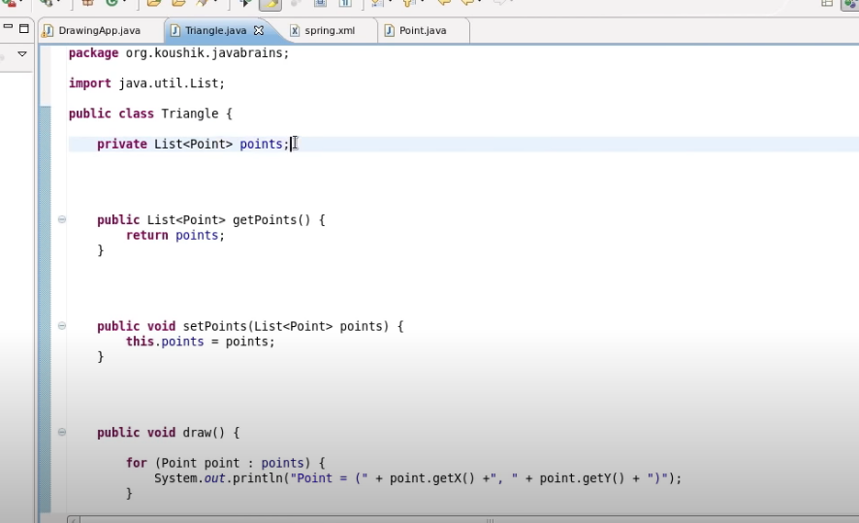

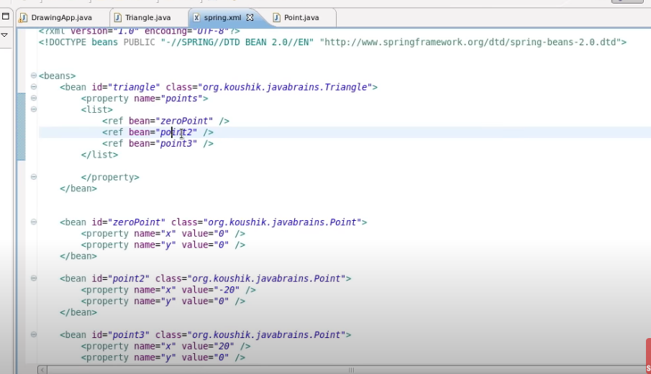

**Autowiring by name**

We may auto-wire the beans by name as displayed below:

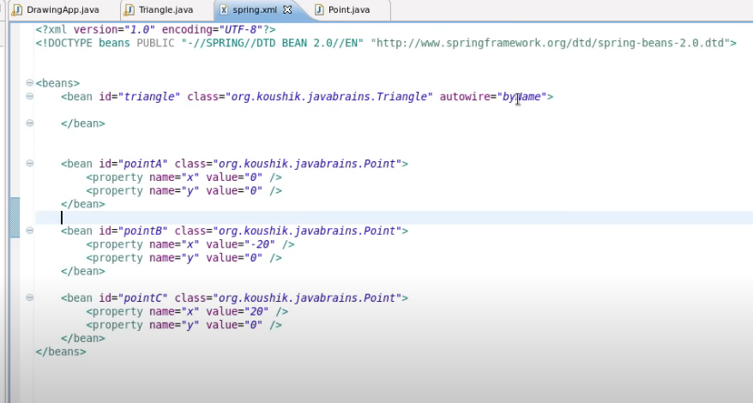

When spring reads the bean of triangle it checks that autowire=”byName” attribute is added so it will compare all the attributes present in Triangle class and inject it’s beans accordingly

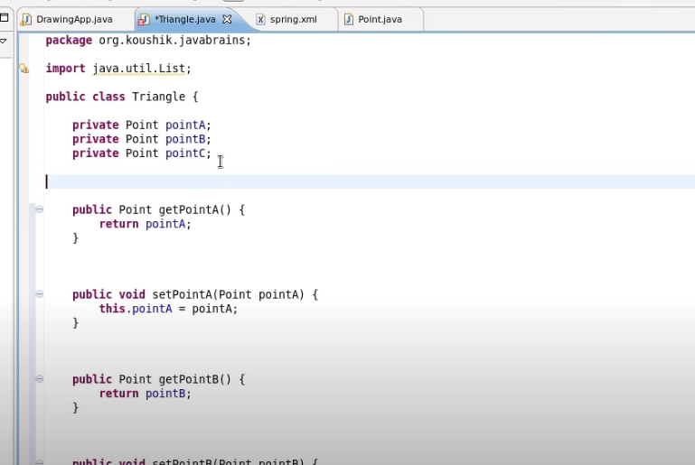

There are also other method of autowire i.e by type in this the type of Object is compared and injected.(Point Object in Triangle class is compared with the type of bean which is mentioned class)

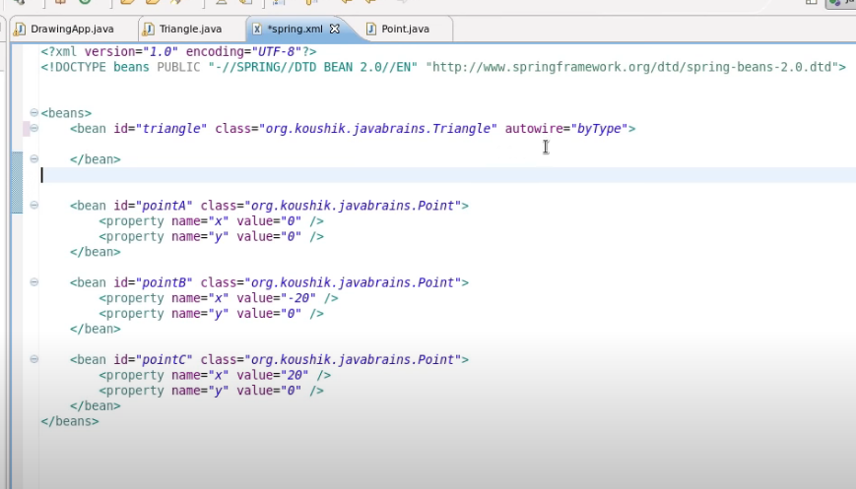

Autowire by constructor

In this autowiring is done by constructor injection.

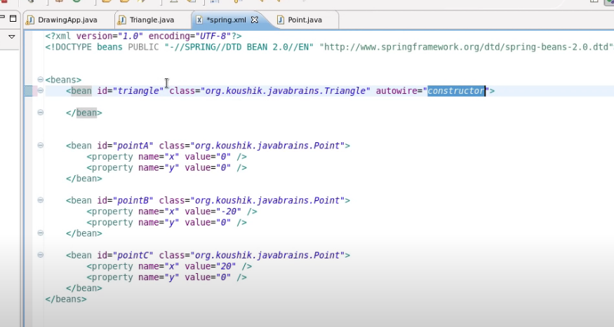

If auto wire attribute is not added then it is automatically off and we have to provide a reference of dependent beans.

But with auto-wiring, it is difficult to check the dependencies because all the dependencies are automatically injected.

BEAN SCOPES

There are 5 bean scopes in spring framework.

|  |  |  |
| --- | --- | --- |
| **No.** | **Scope** | **Description** |
| 1) | singleton | The bean instance will be only once and same instance will be returned by the  IOC container. It is the default scope. |
| 2) | prototype | The bean instance will be created each time when requested. |
| 3) | request | The bean instance will be created per HTTP request. |
| 4) | session | The bean instance will be created per HTTP session. |
| 5) | globalsession | The bean instance will be created per HTTP global session.  It can be used in portlet context only. |

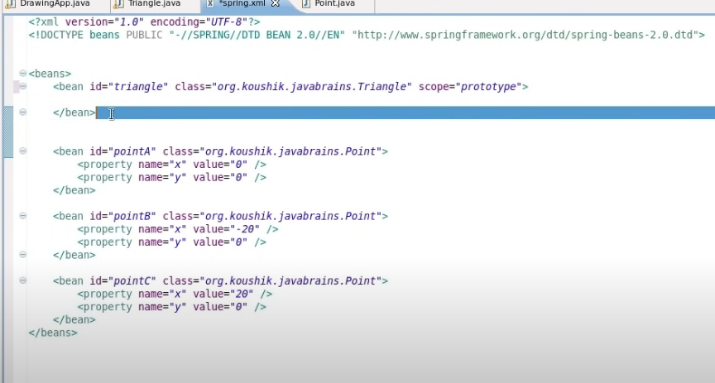

ApplicationContextAware

In order to use the applicationContext object in multiple classes, we may use aware interfaces, we may do so by implementing the ApplicationContextAware interface and implementing it’s unimplemented method. By doing this, the context object would be available and we may be able to access/create instances of beans which has a scope of the prototype(for example Triangle bean has scope singleton and Point bean has scope prototype., in this interface would be helpful ).

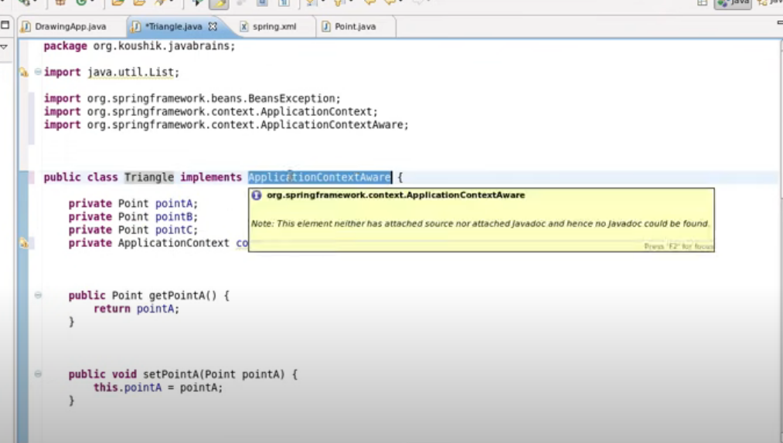

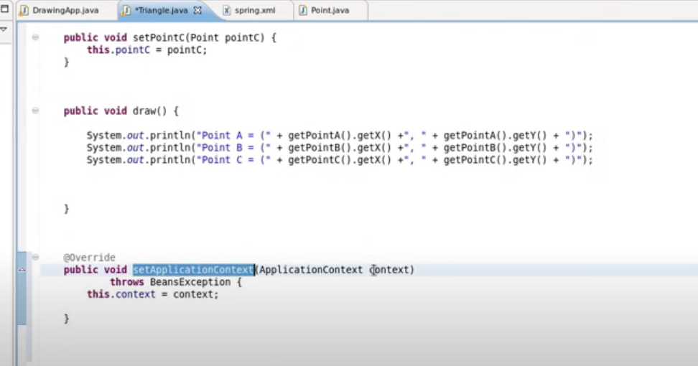

Bean Definition Inheritance

Beans in spring can also be inherited. For Example- In the below scenario, when the bean of triangle1 is created, it inherits parenttriangle bean so there are three beans created when triangle1 bean is created i.e pointA, pointB, pointC.

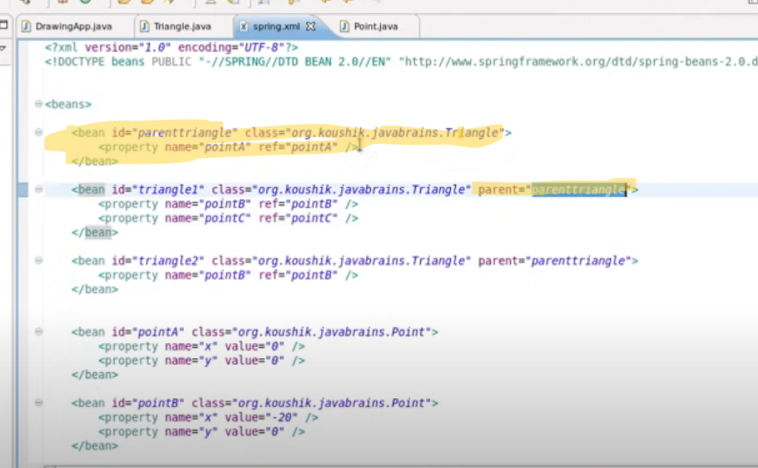

Lifecycle callback

We may also use custom initialization method before the beans are created in spring. For that we may need to use init-method property in spring. Similarily, we may also add destroy-method for clean up code(code that will be executed when beans are destroyed)

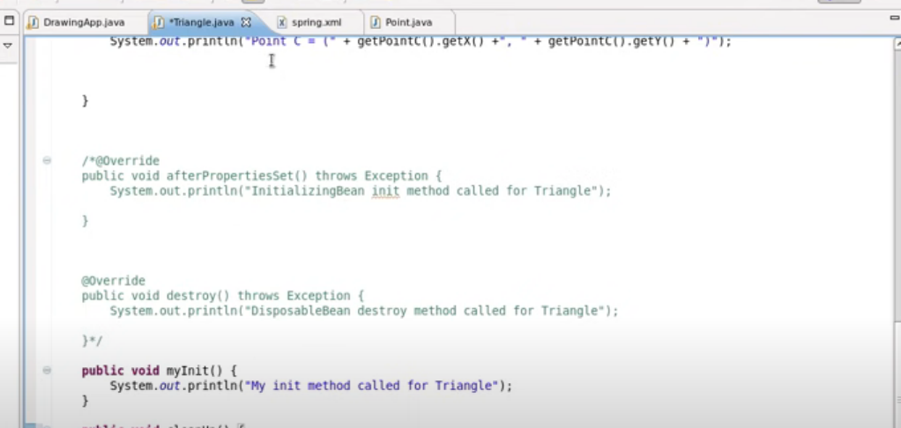

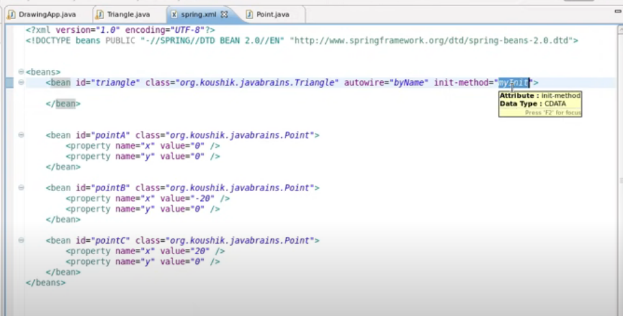

BeanPostProcessor

When a bean is initialized, the bean post-processor method is called. It is a separate class and it is common for all the beans.

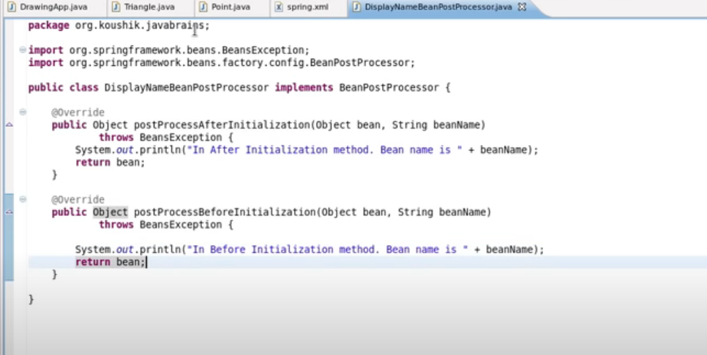

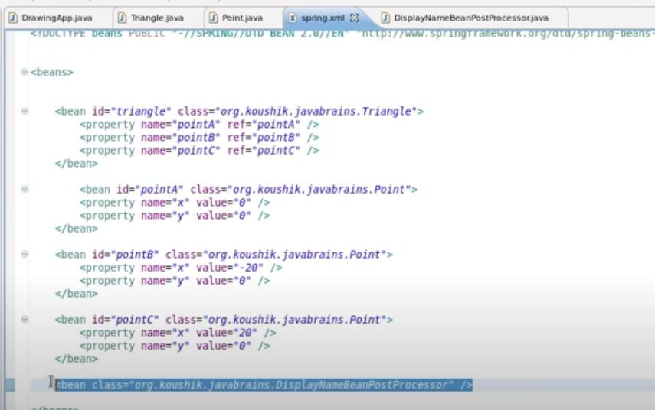

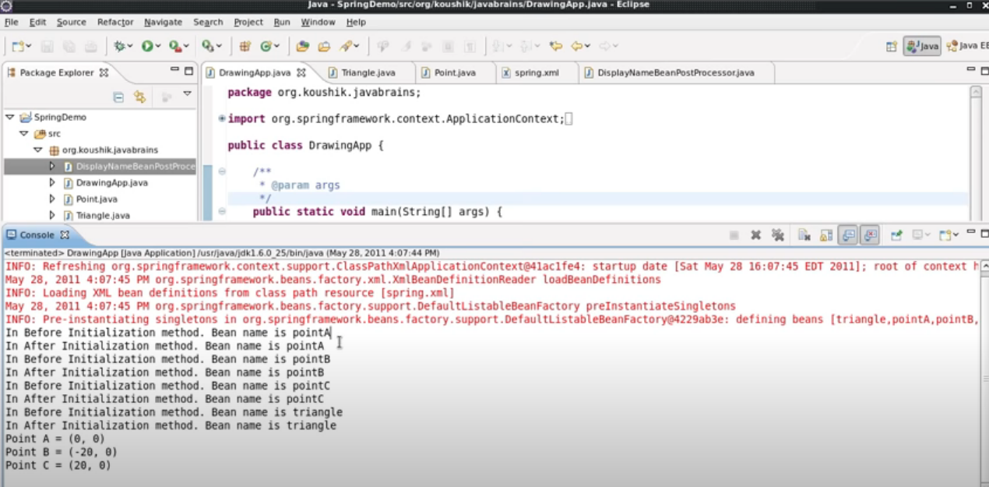

Annotation

BeanPostProcessor actually looks for the annotations and executes them.

Autowired annotation – It first checks for the type of bean in the config file(spring.xml in our case). If there is a single bean, it injects it, but if there are multiple beans of the same type, it checks for names and injects the bean.

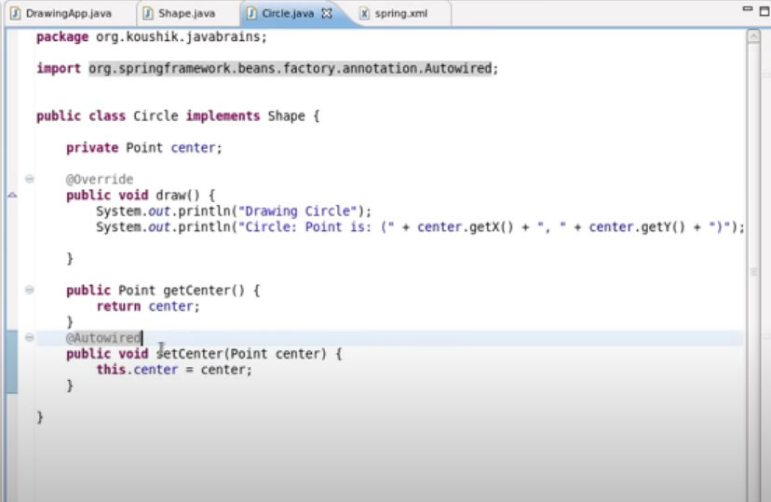

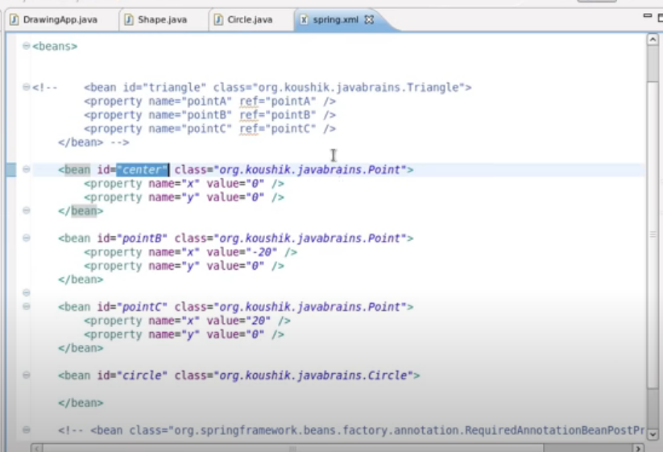

If the name also not matches then it checks for qualifier i.e @Qualifier i.e it checks if the multiple beans of the same has any property related to the qualifier. For example-

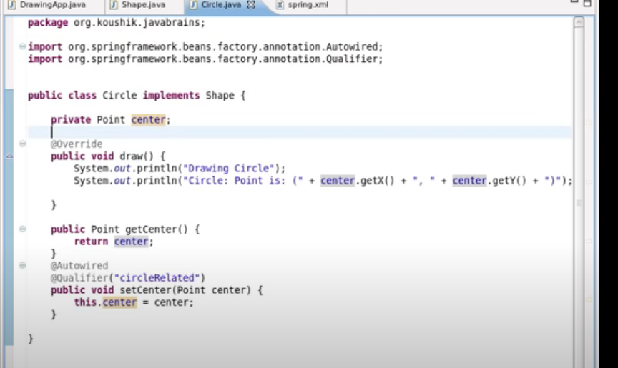

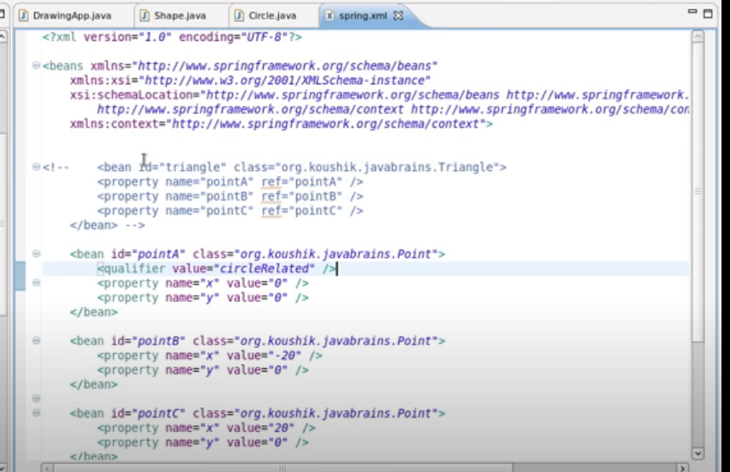

Instead of adding individual bean processor tags(which throws/handles an exception if there is a bean mismatch while running the application especially in case of annotations) in xml,

We may use the below mentioned tag.

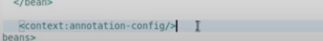

@Resource Annotation

It is used to inject dependencies by name. If name is not metioned then it behaves same as Autowired annotation.

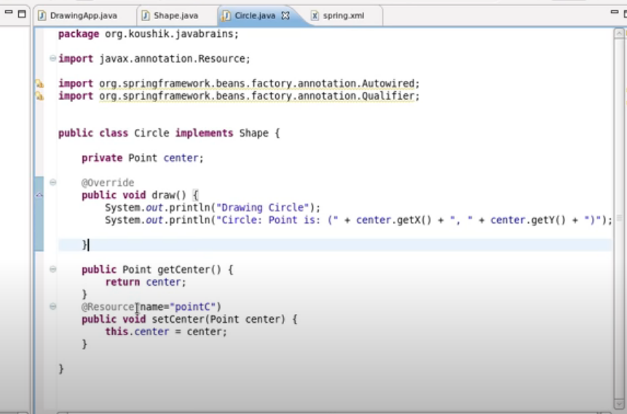

@PostConstruct – It calls the method after the bean is initialized

@PreDestroy - It calls the method after the bean is destroyed.

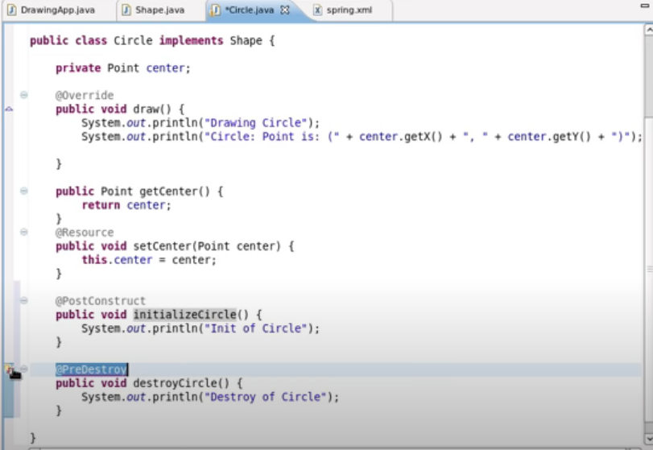

@Component Annotation

If we don’t want to create bean in xml configuration file for a particular class, then we may use @Component Annotation on top of that class. It serves the same purpose.

The below-mentioned attribute is used to tell spring to scan a particular package and looks for beans.



<https://www.geeksforgeeks.org/difference-between-component-repository-service-and-controller-annotations-in-spring/>

**Read message from property file**

In order to read messages from property file, we may use the following annotation, and pass name of that file in the value.

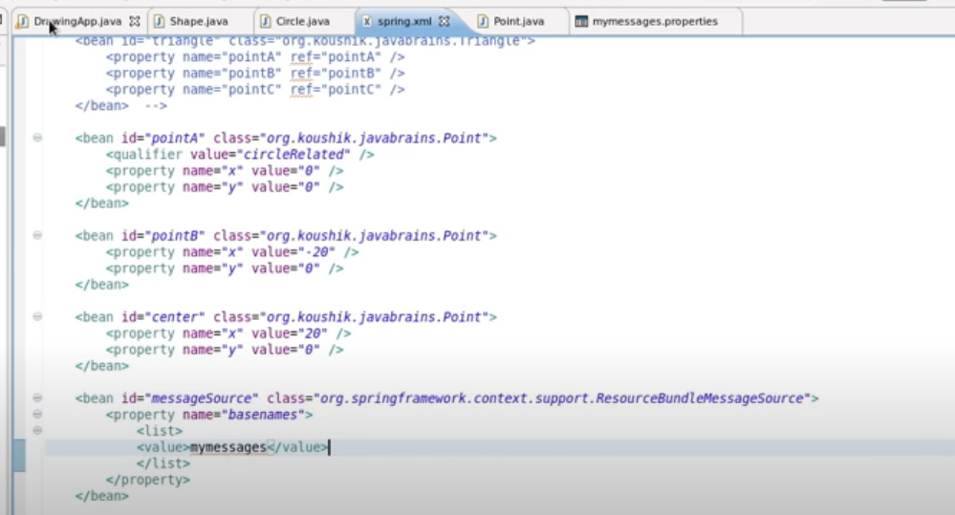

We can read that message as mentioned below:

